- A scenario we’ve run using our Global Economic Model finds that if net inward migration were zero over the longer term, the UK economy could be 15% smaller than our baseline forecast in 2060, with GDP growth averaging just 0.9% a year. In contrast, higher net inflows, in line with the principal population projections from the Office for National Statistics, could result in GDP being 5% higher than our baseline in 2060.
- A scenario where net inward migration is zero over the long term would result in government borrowing rising sharply. Lower tax revenue would more than offset the impact of a smaller population on spending.
- If net inflows were lower, increasing participation in the labour force, particularly among older people, would be essential, with further increases in the state pension age possible. But the fiscal arithmetic of lower net inflows would force the government to confront tougher choices. Abandoning the triple lock on pensions would be imperative, but a broader rethink of government spending would likely be required.
In a recent note, we set out our new, much lower, baseline assumptions for net inward migration over the next five years. But we flagged there was significant uncertainty around the assumptions further out because of the uncertainty around immigration policy, which can vary considerably across different governments.
In this briefing, we set out two alternative scenarios for net inward migration to provide a range of plausible outcomes. These results demonstrate the importance of migration assumptions – running these profiles through our Global Economic Model, we find that by 2060, GDP is 5% above our baseline forecast in the upside scenario, but more than 15% below in our zero net migration variant (Chart 1).
Chart 1: Varying our migration assumptions has a marked impact on the long-term GDP outlook
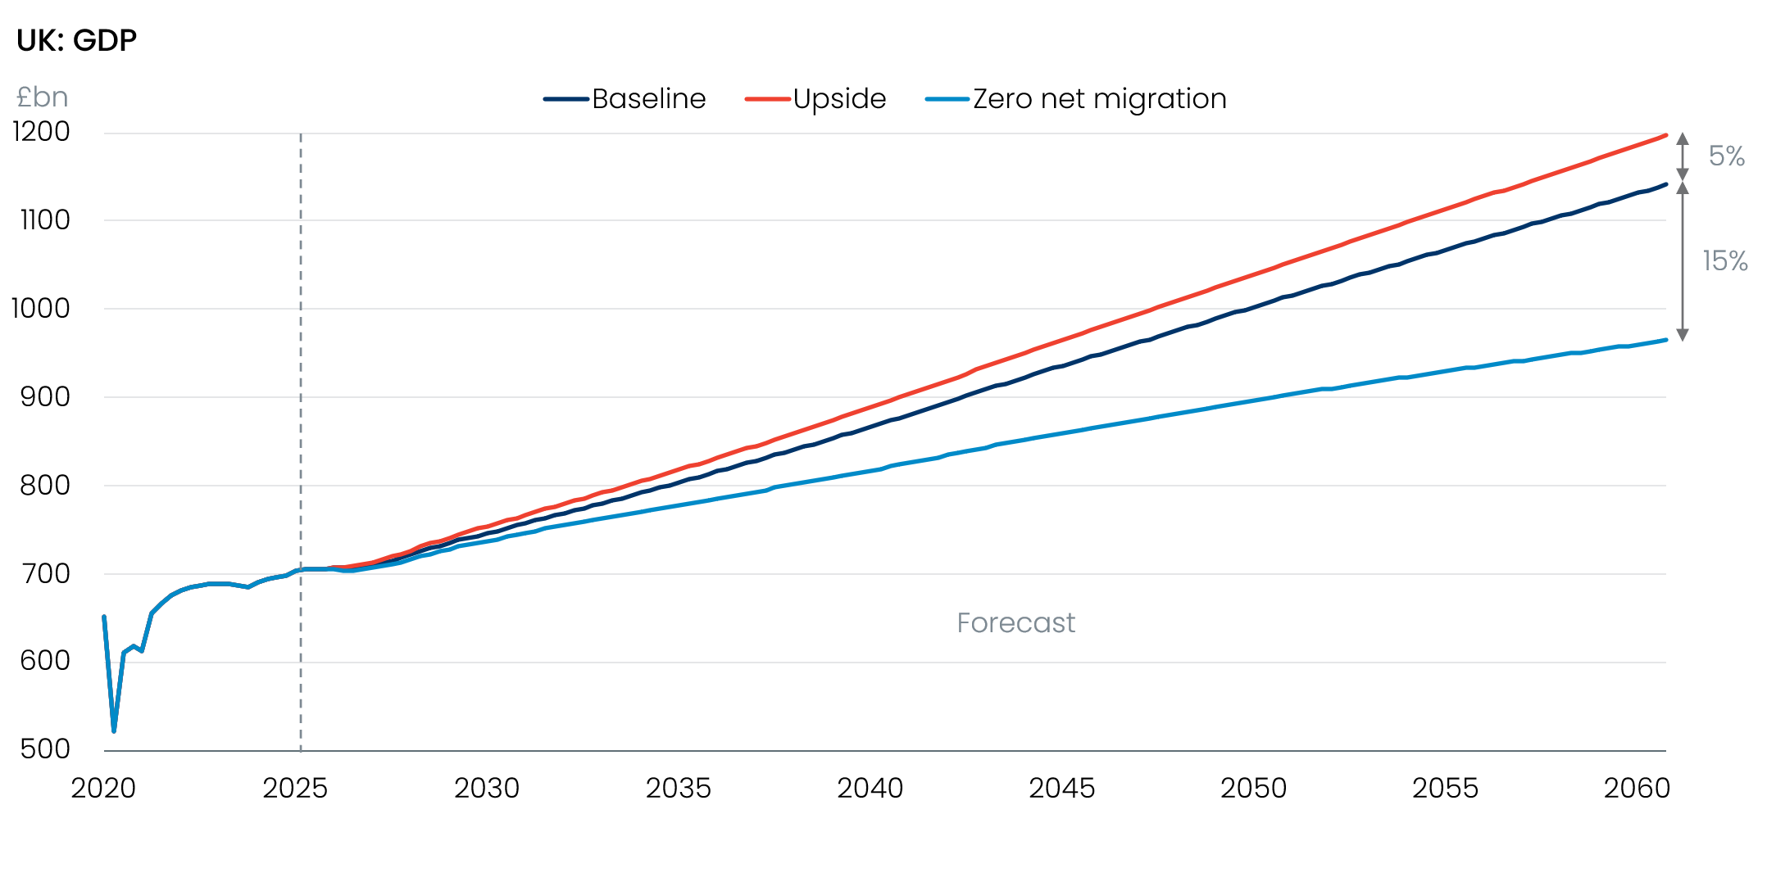
Sources: Oxford Economics, Haver Analytics

We’ve modelled two scenarios to offer a range of plausible outcomes
Our upside scenario adopts the Office for National Statistics’ principal population projections, published in January 2025. The ONS published these projections prior to implementing a series of methodological changes that suggest emigration has been much higher than previously assumed in recent years. Since the projections were published, it’s also become clear that measures to tighten visa criteria implemented by the previous government have caused a much greater than expected drop in immigration.
The upside scenario assumes net inflows average 354,000 a year over the next five years, compared with 169,000 a year in our baseline forecast. Over the longer term, net inward migration averages 340,000 a year, compared with our baseline of 272,000 a year (Chart 2).
Chart 2: Our scenarios bookend the range of plausible outcomes
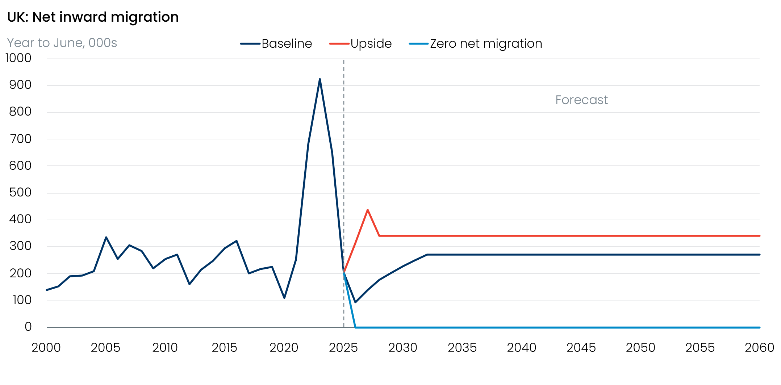
Sources: Oxford Economics, ONS
Our downside scenario assumes that net inward migration is zero from 2026 onwards. This scenario might appear extreme – the last time that net inflows were as low as zero was 1993. But our baseline forecast shows net inward migration dropping to just 96,000 this year, and that projection assumes the recent steep rise in emigration stops and the plunge in visa applications levels off – if either trend continues, net inflows could easily fall to zero.
Similarly, an assumption that net inflows average zero appears conceivable given the current political climate. Despite evidence of a substantial drop in net immigration, the government and key opposition parties continue to advocate reducing levels further. In November, the government presented a white paper on asylum that proposed making it harder for refugees to settle in the UK permanently. It also announced a consultation on settlement rules, suggesting migrants who entered illegally, overstayed a visa, or claimed benefits would have to wait longer for permanent settlement. Those with permanent status but not citizenship would also find their access to welfare benefits restricted. If adopted, these measures will likely reduce the attractiveness of the UK as a destination for migrants, although it’s hard to quantify how much they will reduce inflows.
It’s also possible that future governments will pursue even tighter immigration policies. Reform UK currently lead most opinion polls and their policies include abolishing indefinite leave to remain (ILR), a status that the Migration Observatory estimates covers 622,000-800,000 people. Indeed, Reform UK has vowed to go further and rescind existing ILR awards. Changing someone’s immigration status retrospectively would be unusual, and if this principle were extended to other statuses, it could result in much larger numbers of people leaving the UK.

Zero net migration would result in a persistently declining workforce
Migrants are typically of working age, particularly now that there are stricter visa requirements in place for dependents. Therefore, varying the level of net inflows has a material impact on the size of the workforce. Over the past two decades, high levels of net inward migration have mitigated the impact of ageing and, along with a sizeable increase in the state pension age, ensured that the working-age population has grown strongly.
Our upside scenario sees the working-age population continuing to grow, albeit at a slower pace than in the past, until the late 2050s. At the end of 2060, the working-age population would be around 2.5mn (5%) larger than in our baseline forecast.
By contrast, our zero net migration scenario would see the working-age population begin to decline from the end of this decade. As the population ages, the pace of decline in the working-age population would quicken, only being arrested by the increase in the state pension age in 2044-2046 (Chart 3). By 2060, the working-age population would be 7.6mn (16%) smaller than in our baseline forecast.
Chart 3: If net inflows were zero, the working-age population would start falling from the late 2020s
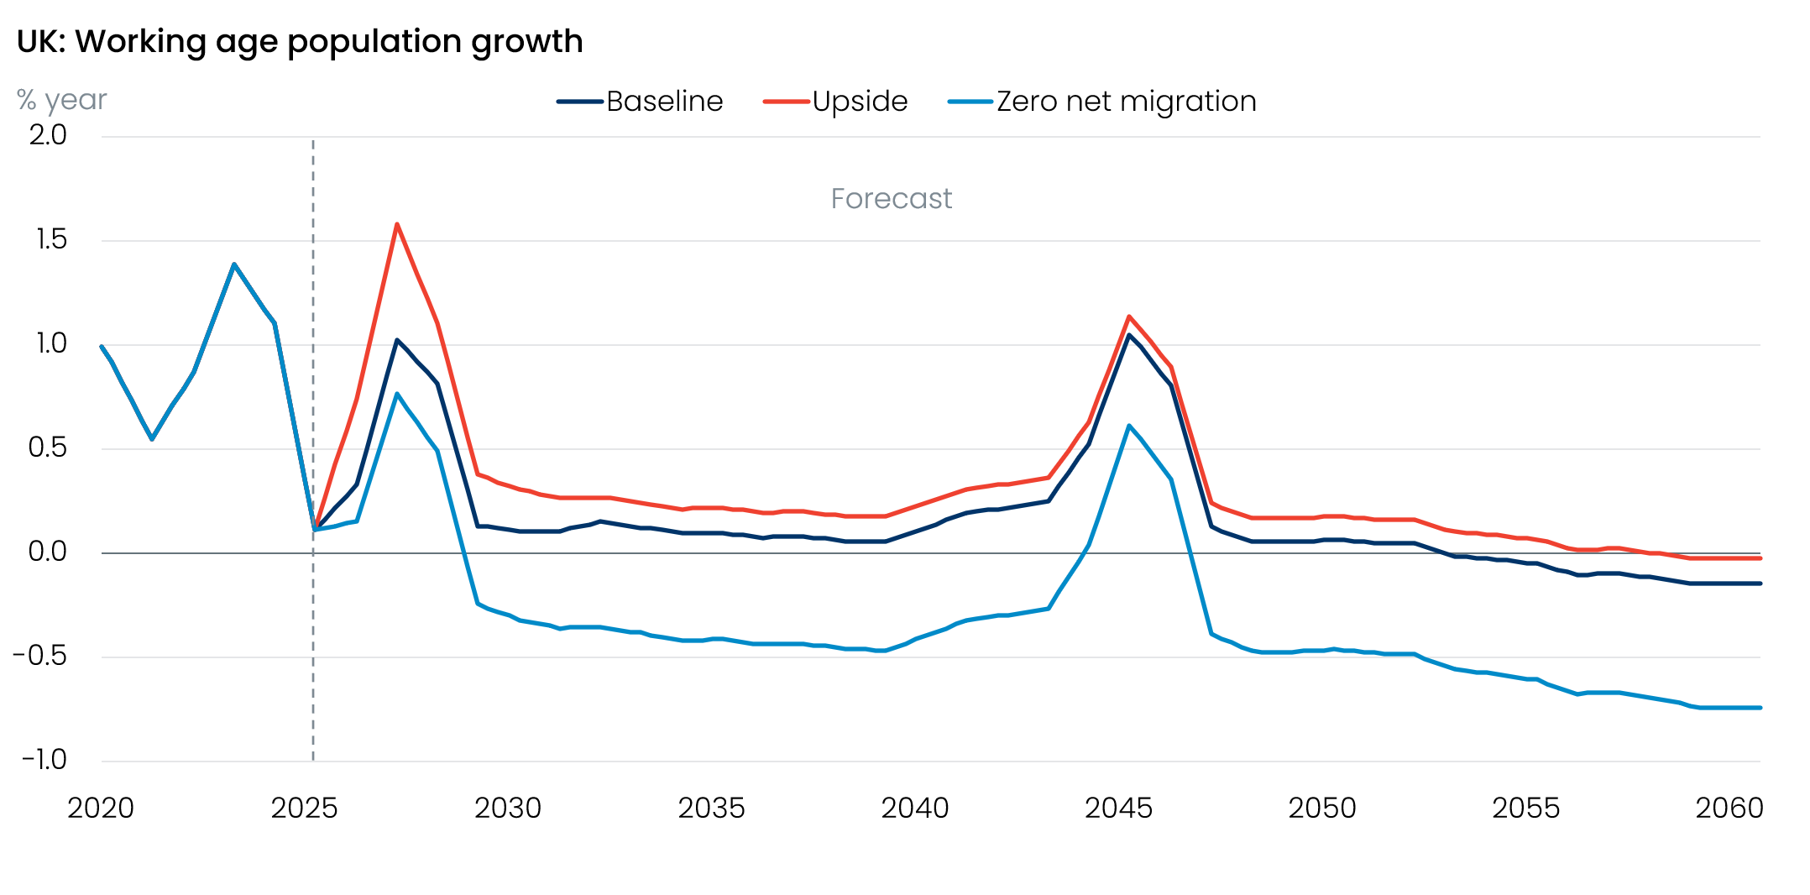
Sources: Oxford Economics, Haver Analytics

Different population assumptions affect potential output via labour supply and capital deepening
In our Global Economic Model, underlying growth rates over the long run are determined by supply factors – the capital stock, the labour supply adjusted for human capital, and total factor productivity. The different assumptions for the working-age population have a direct impact on potential output growth via labour supply. But there are also important indirect effects. Different population assumptions imply different levels of demand. This, in turn, affects investment and the degree of capital deepening.
In our upside scenario, stronger labour supply and greater capital deepening mean that GDP growth is 0.1ppt-0.2ppts a year stronger than in our baseline forecast out to 2060, leaving the level of GDP just under 5% higher at the end of the forecast horizon (Chart 1).
By contrast, the zero net migration scenario results in GDP growth being 0.5ppts a year lower than our baseline forecast, leaving the level of GDP more than 15% lower in 2060. The larger difference in the zero net migration scenario reflects the fact that the difference in migration assumption compared with our baseline is much larger than it is for the upside scenario.

Fiscal implications of zero net migration would be significant
Arguably, the most striking results relate to the public finances. Our baseline forecast assumes that over the medium term, the fiscal challenges associated with dealing with an ageing population result in governments running modest public sector current budget deficits. This forecast doesn’t comply with the current fiscal rules, but it’s consistent with the behaviour of recent administrations. Successive governments have set fiscal targets but judged them on a rolling basis. This has meant the targets have rarely been achieved, but they have been judged compliant with the fiscal rules because they would be achieved by future policy tightening. This tightening is then typically watered down, delayed, or offset by other measures that loosen the fiscal stance.
In constructing our scenarios, we’ve assumed that all other policies remain unchanged. On this basis, the UK would run slightly smaller current budget deficits in our upside scenario, resulting in a smaller increase in public sector net financial liabilities as a share of GDP (Chart 4).
Chart 4: Zero net migration would result in much higher government borrowing and rising debt levels
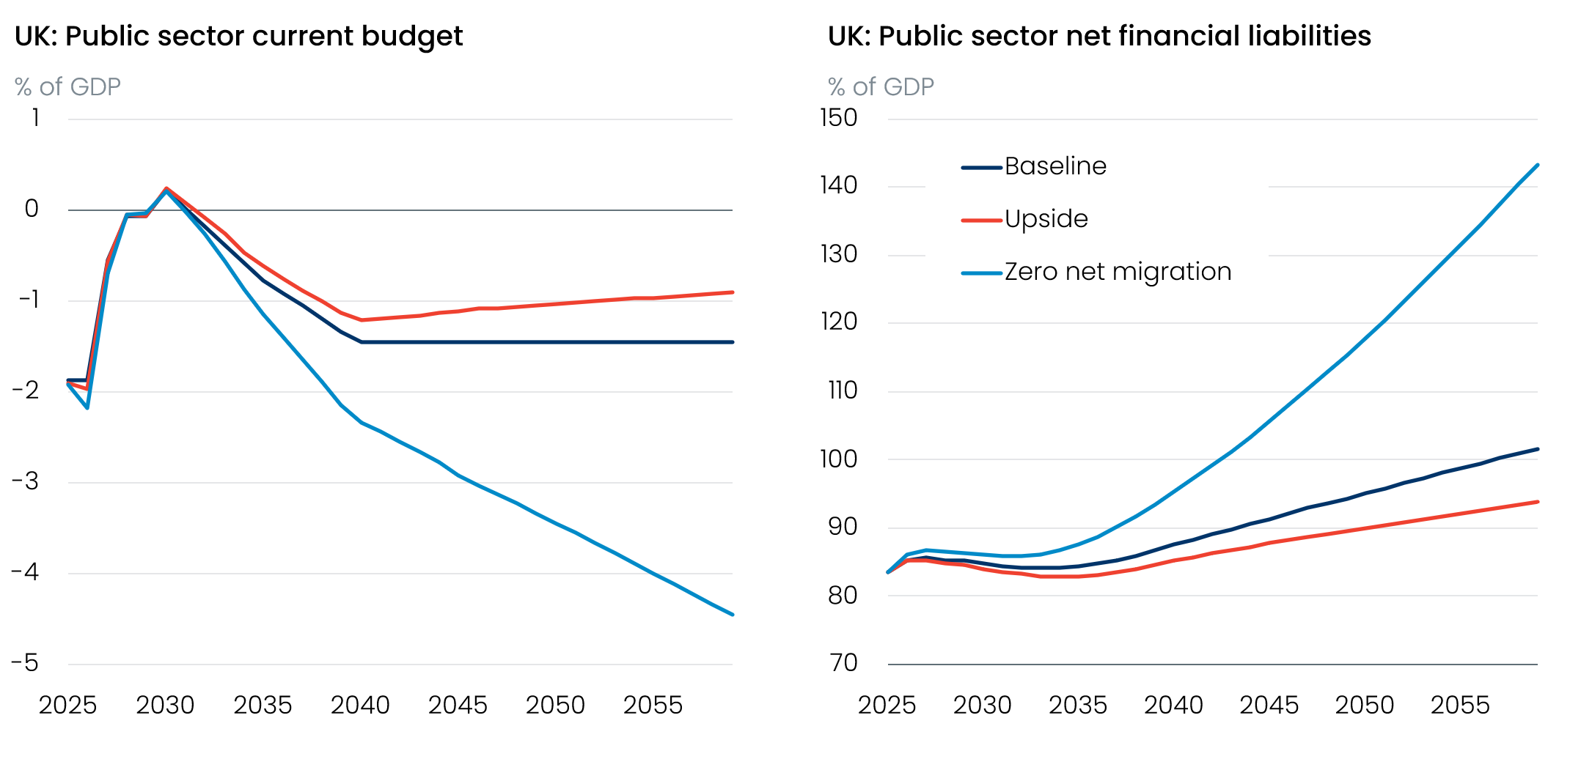
Sources: Oxford Economics, Haver Analytics
In our zero net migration scenario, the current budget deficit widens progressively over time, exceeding 4% of GDP by 2060. Lower economic growth hits tax revenue. Government current and capital spending are also lower because the smaller population requires fewer people to be educated and treated by the National Health Service. But the cuts in spending are much smaller than the fall in revenue. Higher borrowing means higher levels of public debt – public sector net financial liabilities as a share of GDP would be 40ppts higher in 2060 compared with our baseline forecast.

Lower immigration could lead to skills shortages in some sectors
As well as resulting in weaker economic growth, the zero net migration scenario would pose some practical challenges. On average, 20% of employees are non-UK nationals, but some sectors are much more reliant on migrant workers (Chart 5). More than one-third of employees in administrative services are non-UK nationals, and in hospitality and health, the shares are more than one-quarter. Much lower levels of immigration would threaten to worsen skills shortages in these sectors, repeating the post-pandemic experience.
Chart 5: More than one-third of workers in administrative services are non-UK nationals
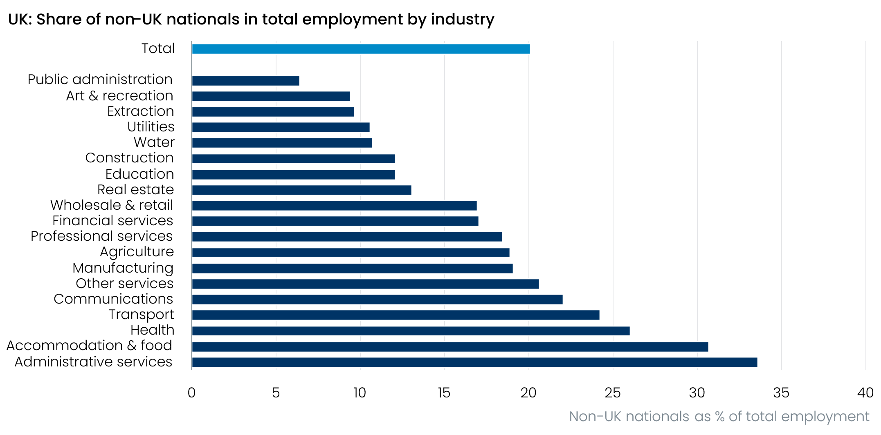
Source: Oxford Economics calculations using data from HMRC

Governments would also be forced to confront tough fiscal policy choices
In addition, the fiscal deterioration in the zero net migration scenario would quickly prove unsustainable and would likely hasten some tough policy choices that the UK has so far been reluctant to confront.
As we’ve already argued, a combination of high levels of net inward migration and a rising state pension age has mitigated the impact of an ageing population on labour supply and economic growth. The old-age dependency ratio (the number of people above the state pension age as a percentage of the number of people of working age) increased to 30.1 in 2025, up from 25.8 in 2000. But that was the smallest increase of the G7 nations, with the other three European G7 nations seeing increases ranging from 9.5ppts to 10.8ppts, and Japan’s ratio rising by 25.5ppts.
However, after the current increase in the state pension age (which will rise to 67 from 66 during 2026 to 2028), there’s just one more single-year rise– to 68 between 2044 and 2046 – currently legislated for. If there are also far fewer working-age migrants moving to the UK, the old-age dependency ratio will rise significantly – in our zero net migration scenario, the old-age dependency ratio rises by just under 20ppts to 49.8 in 2060, a 7.8ppts increase compared with our baseline forecast (Chart 6).
Chart 6: Immigration and a rising state pension age have previously mitigated the impact of population ageing
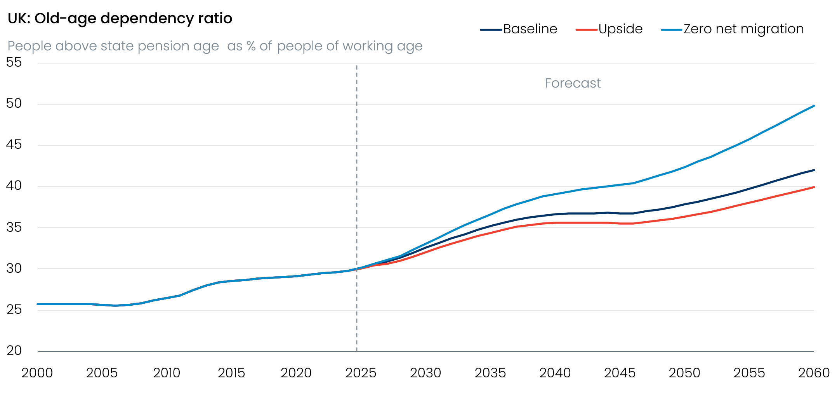
Sources: Oxford Economics, Haver Analytics

Lower immigration would need to be mitigated by higher participation, particularly by older people
To mitigate the potential for skills shortages and unsustainable public finances, there would be a clear need to increase workforce participation. Adding further increases in the state pension age would be one way of achieving this. Previous experience suggests that a one-year rise in the state pension age lifts the workforce participation rate of those directly affected by nearly 10ppts. This move would also have the benefit of cutting government spending on the state pension.
But UK politics has become increasingly short-termist in recent years, and the current fragmented state of party support is only likely to further discourage long-term decision-making. Moreover, people need to plan retirement well in advance – the previous government committed to giving at least 10 years’ notice of any increase in the state pension age. So any acceleration of the current timetable is unlikely to take effect any time soon.
Given the challenges associated with increasing the state pension age, it would be even more important that the government pursues policies that encourage participation among older workers. The UK employment rate for 65–69-year-olds is in line with the OECD average, but for the 70-74 age group, the UK rate is lower, and it lags well behind that of countries like the US, South Korea, Japan, and New Zealand.
In our plan for growth, we set out a series of ideas for encouraging older people to remain in the workforce. These include more preferential tax treatment of older workers and measures to improve access to workplace pension schemes for workers above the state pension age.
As well as helping to alleviate skills shortages, those measures would boost tax receipts via stronger GDP growth. But in the zero net migration scenario, governments would likely face tough choices on government spending, too.
The most obvious casualty would surely be the triple lock, which raises the state pension by the highest of CPI inflation, average earnings growth, or 2.5%. The Office for Budget Responsibility estimates that the policy will cost £15.5bn a year by 2029-2030, three times more than initial expectations. The official forecaster also projects that the triple lock will account for 1.6ppts of a 2.7% of GDP rise in spending on the state pension by the early 2070s. Even under our baseline assumptions, we think the triple lock is unaffordable and should be replaced by indexation to earnings. Under a lower immigration scenario, where the fiscal arithmetic becomes even more challenging, the replacement of the triple lock becomes more pressing still.
The extent of the fiscal deterioration in the zero net migration scenario means there would also likely be a need for governments to make cost savings elsewhere. But an ageing population will require more resources to be devoted to healthcare, the UK is committed to a significant increase in defence spending, and spending on non-core government departments has already been cut significantly since the global financial crisis. In this context, cutting spending further while maintaining similar levels of public service provision will be very difficult, particularly if public sector productivity remains so poor. There may need to be a rethink about whether some aspects of state provision, such as a National Health Service that is free to all at the point of use, can still be maintained.
A global version of the zero net migration scenario will feature in our next Megatrends Scenarios release in May.

